1、query the website to download the APP
https://dealer-ios.github.io/Mobile-APP/app_download.html

2、For the first installation, need to trust the developer certificate
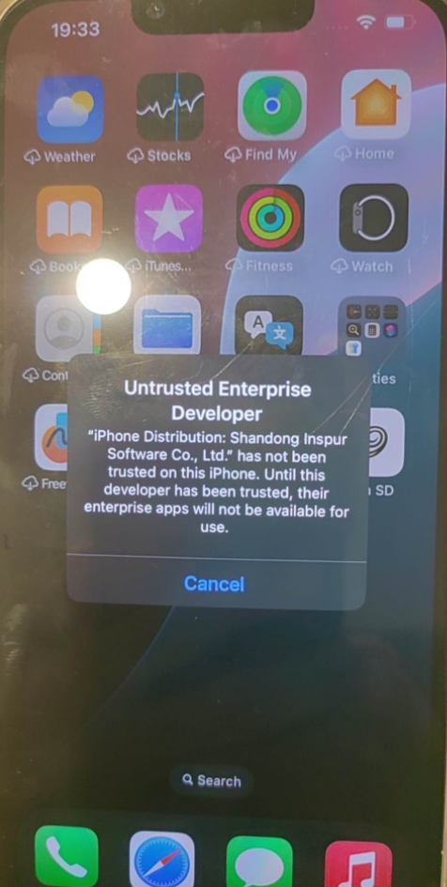

3、Open Settings and click General
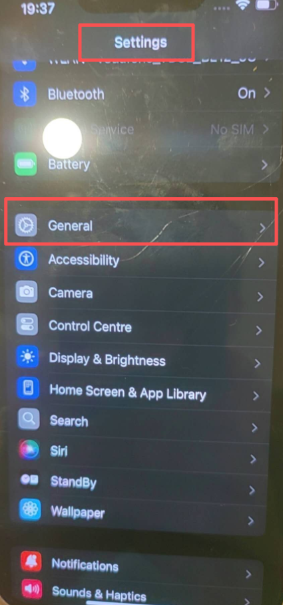

4、click VPN&Device Management
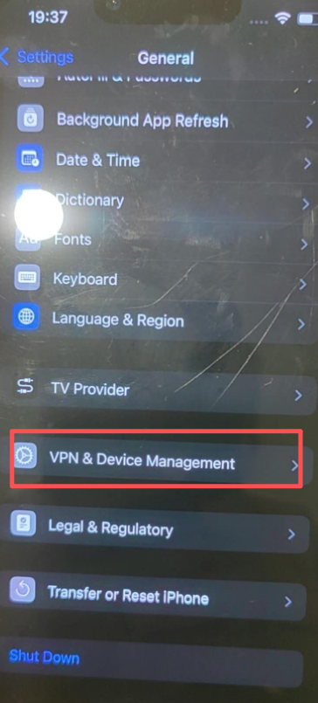

5、Click on the certificate
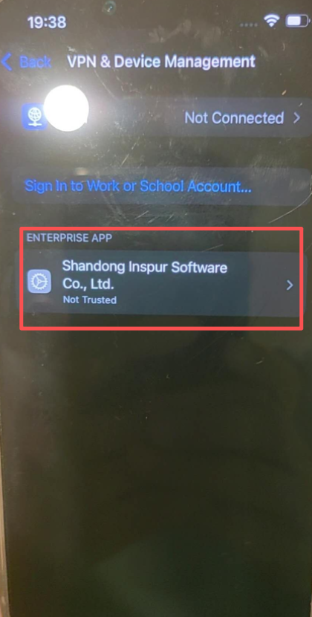

6、Trust the certificate
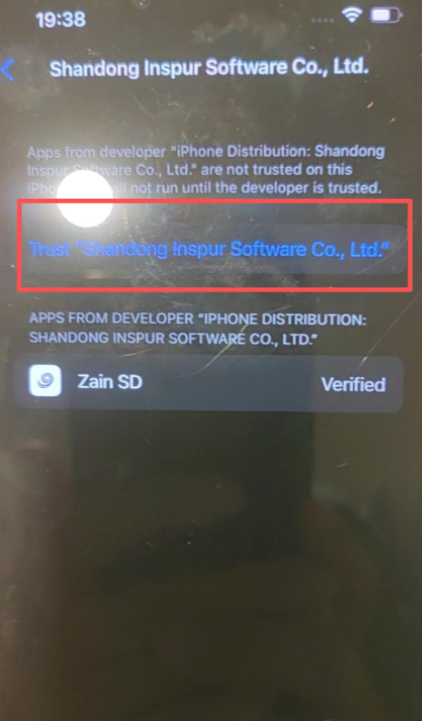

7、Allow&Restart cell phone
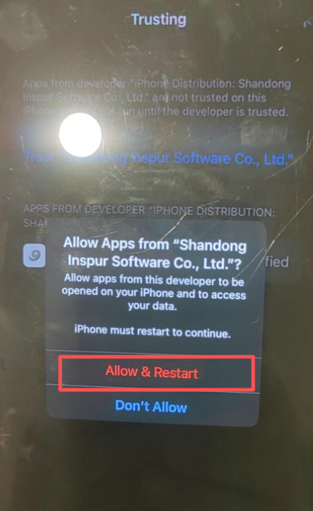

8、After restarting the phone, click install profile
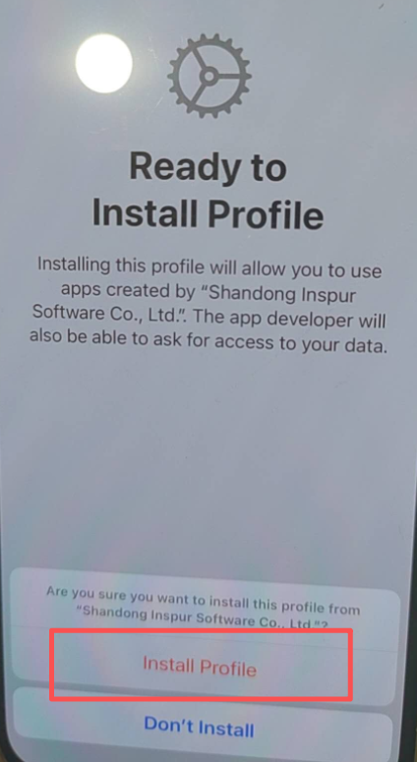

9、Complete the above steps and click Zain SD APP to log in

